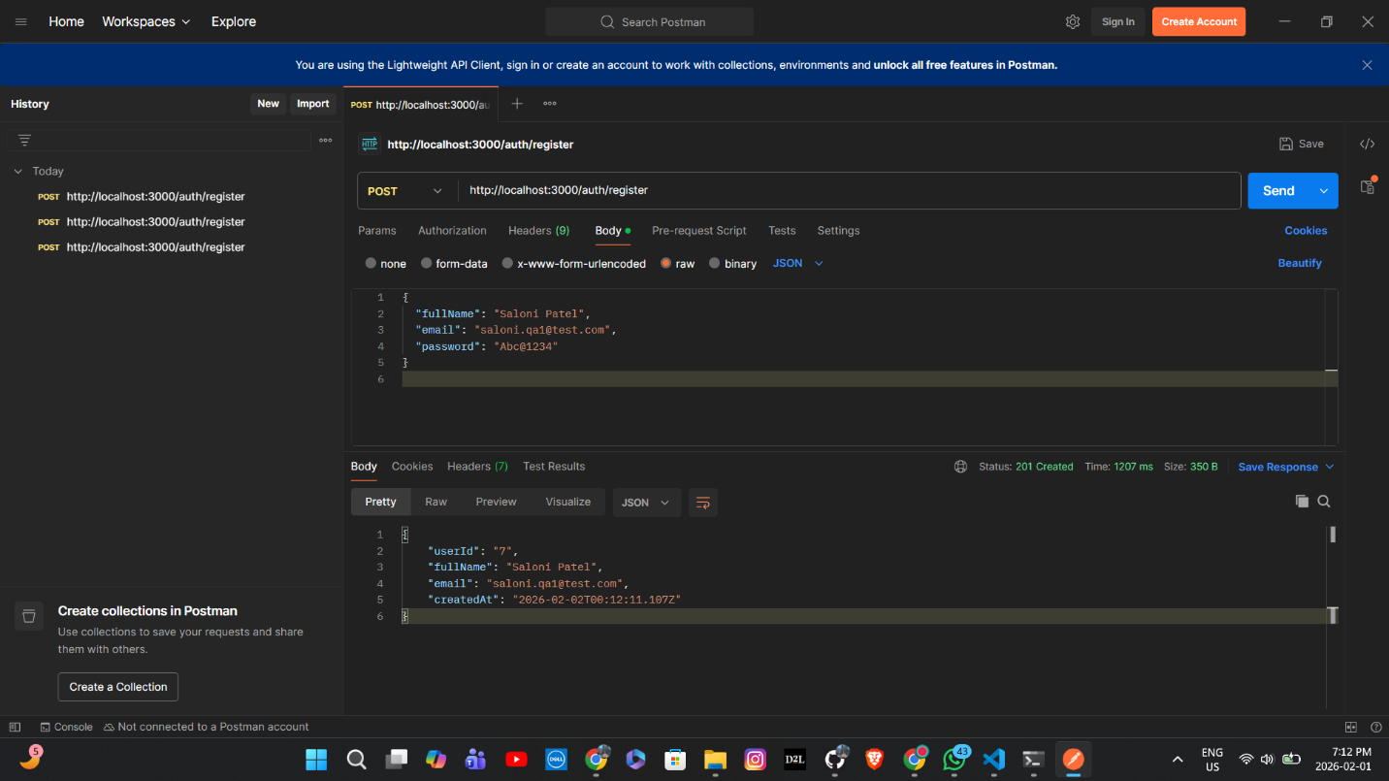
- Test case-1 : Registered with new user

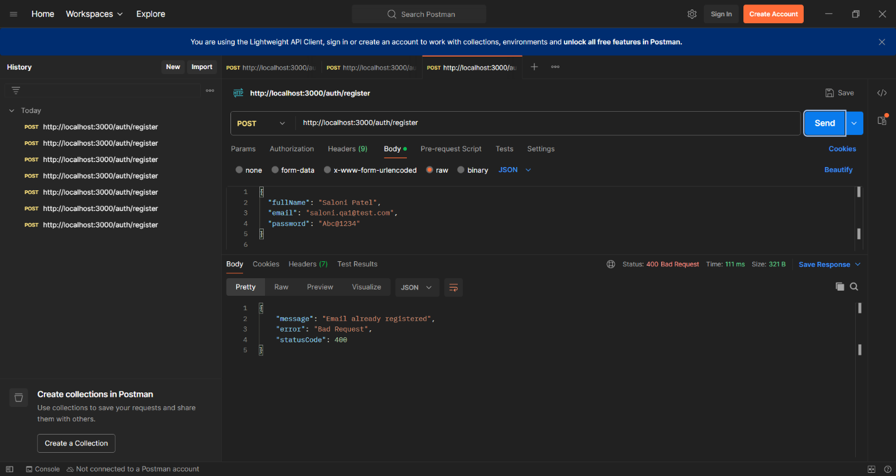
- Test case-2 : Tried registering again with same credentials

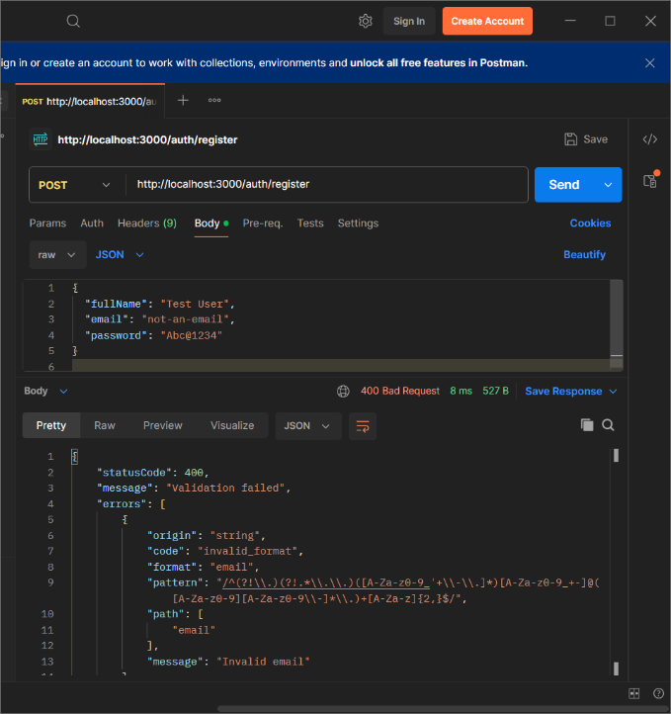
- Test case-3: showed an error because of wrong email format

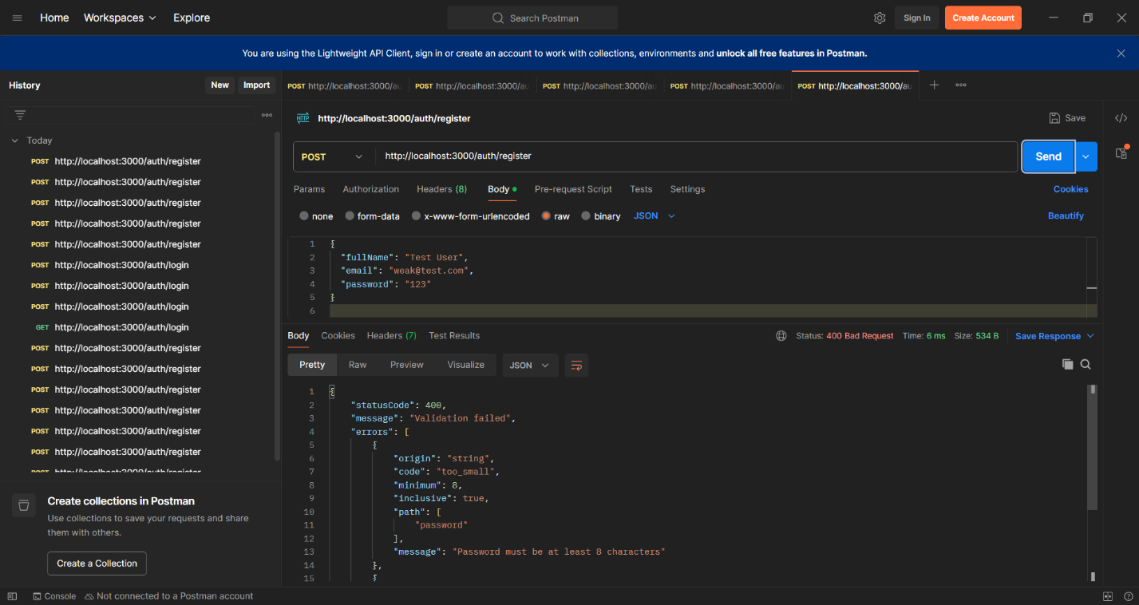
- Test case-4: Showed an error for password as it does not follow the password format

- Test case-5: wrong password error
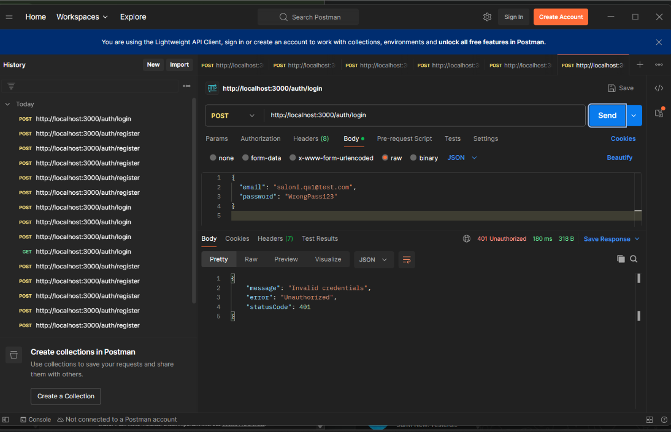

- Test case-6: Login without registration
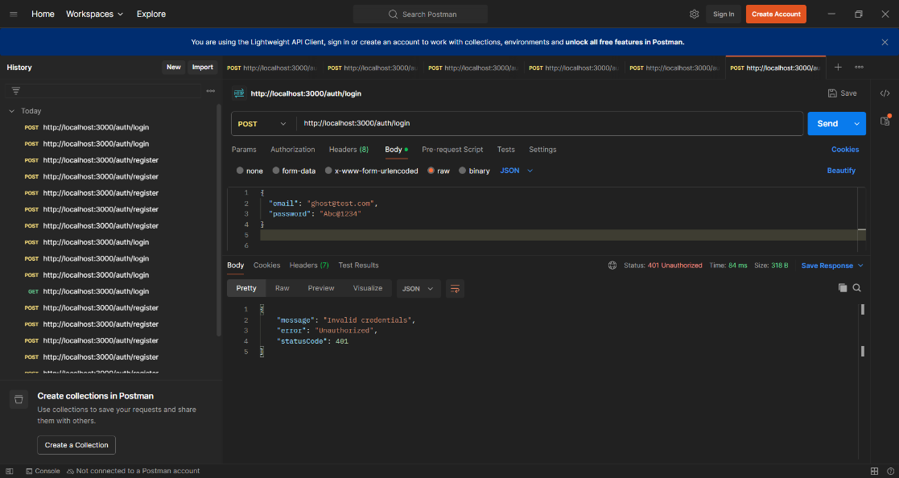

bhfvjc
- Test case- Registered a new user agian
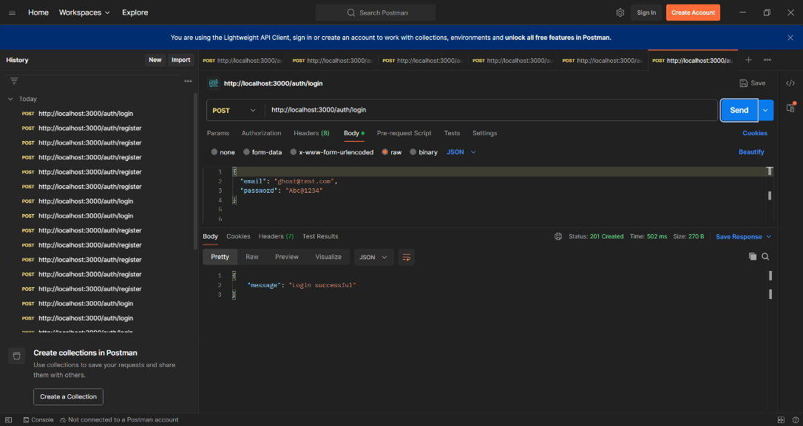
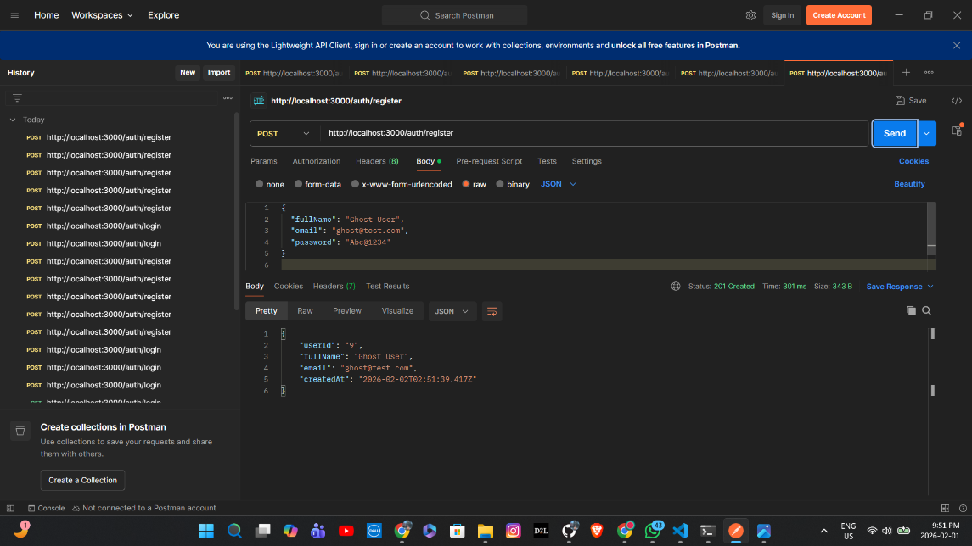

- Test case-7: Login now successful

